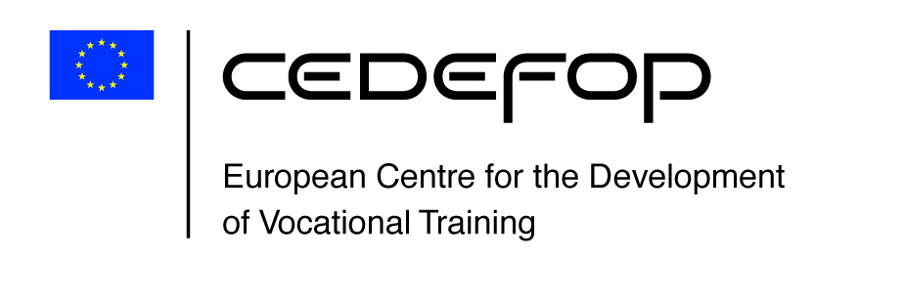

Towards a structured and consistent terminology on transversal skills and competences

3rd report to ESCO Member States Working Group on a terminology for transversal skills and competences (TSCs)
02 June 2021
John Hart, Martin Noack, Claudia Plaimauer (External experts) and Jens Bjørnåvold (Cedefop) ()

Introduction

This final report of the ESCO/EQF expert group on transversal skills and competences outlines a terminology on transversal skills and competences. While primarily designed to strengthen the existing ESCO terminology on transversal skills and competences, the terminology will be relevant for many different purposes, related to labor markets and education and training system.

1.1 The mandate
The expert group was mandated (2019), by the ESCO Member States Working Group and the European Qualifications Framework Advisory Group, to refine and structure the existing ESCO terminology on transversal skills and competences. Based on a systematic analysis of existing approaches in this area, the group has tried to position the terminology in a wider context of research (), policies and common usage. The result, presented in this final report, is a terminological map clarifying the scope of and relationship between transversal skills and competences. The working group observes that transversal skills and competences are understood in different and sometimes contradictory ways. There is a tendency for each institution and each researcher to restart and duplicate terminological work. While this partly reflects that need to adapt to different purposes and settings, a lack of common ground complicates dialogue and cooperation. A lacking understanding of what is meant by transversal skills and competences makes it difficult to decide on political and practical follow up. Building on the increasing terminological influence of ESCO and EQF in Europe (and beyond), the current proposal will hopefully contribute to clarify what is meant by transversal skills and competences and result in a better dialogue.

1.2 The work of the expert group
This is the final delivery of the expert group on transversal skills and competences. The work of the expert group can be described as follows:
- The initial stage of the work (until mid-2020) was used to identify and analyse existing terminological material. This work resulted in the collection of terms included in a technical annex to be published separately. This initial analysis made it possible for the group to define the scope of the terminology, to clarify the meaning of and relationship between terms and to indicate where to categorise and cluster these.
- In the final stage of the work (autumn 2020/spring 2021) a preliminary proposal was presented to and discussed with the ESCO Member State Working Group. This feed-back from the member states provided the basis for a final set of revisions and refinements, the results of which are presented in this report. The final revision was significantly strengthened by the initiative of the Bertelsmann Foundation to develop a German language version of the model. Working in two languages helped the expert group to identify and address weaknesses in the original proposal. A testing of the model was carried out in cooperation with researchers at the Berlin Humboldt University.
- The expert group has throughout the process documented the steps taken to make it possible to identify sources and make it possible for future users to benefit from these.
- The report demonstrates how the transversal skills and competences already contained in ESCO version 1.0 () have been integrated into the proposal.
- Throughout the process the expert group has identified a wide range of literature and research related to transversal skills and competences. Cedefop has taken first steps to make this material available in a publicly available database. When realised, this resource will make it possible for users to make more sense of this important but also complex field of work.

Principles underpinning the TSC terminology

The expert group based the TSC taxonomy on the following key principles ():
- The TSC terminology refers to both “skills and competences”, signalling (a) the extensive use of both concepts in national and international contexts and (b) the significant differences in the iterpretation of these concepts ().
- The terms “skills” and “competences” refer to learned capacities to apply knowledge, know-how, methods or instruments to complete tasks, carry out processes, and/or address changes or problems in a wide variety of contexts.
- Skills are narrower than competences, in the sense that they refer more to basic, pre-defined, or routine procedures, while competences are broader than skills, referring to proven abilities in new and complex situations and/or in the face of unforeseen challenges or issues.
- The headline ‘Transversal skills and competences” signals the comprehensive nature of the taxonomy; reflecting that alternative headlines like “soft”, “non-cognitive”, “socio-emotional”, “key and “core” skills and/or competences frequently address a more limited set of skills and competences ().
- The TSCs are limited to descriptions of behaviours which can be learned, developed and demonstrated.
- Knowledge concepts are not included separately in the taxonomy; knowledge is understood as an integral component of skills and competences.
- Attitudes and values are only included to the extent that they can be learned and developed.
- Transversal skills and competences can be both “basic” and “advanced” and thus relevant to routine as well as non-routine contexts ().
- An adapted version of the three main categories identified by the US National Research Council (2012) forms the basis for the “Thinking’, ‘Self-management’ and ‘Social and communication’ skills and competence categories of the terminology.
- The terminology is designed to be used in a wider setting, for all areas of life, including labour market and education and training contexts.

Defining transversal skills and competences

The expert group, based on the principles listed above, defines transversal skills and competences as follows:

“Transversal skills and competences (TSCs) are learned and proven abilities which are commonly seen as necessary or valuable for effective action in virtually any kind of work, learning or life activity. They are “transversal” because they are not exclusively related to any particular context (job, occupation, academic discipline, civic or community engagement, occupational sector, group of occupational sectors, etc.).”

In a world facing rapid technological and social change, this transversality - and implied transferability - is seen as increasingly important. The expert group notes that transversality can be linked to what is termed “deeper learning”, pointing to skills and competences underpinning and enabling the more specific skills required for example in a work setting. The 2012 report “Transferable knowledge and skills in the 21st Century’” published by the US National Research Council () provides an important overview of research in this area, elaborating on the extent to which this transferability is achievable or not. The expert group has taken due note of the conclusions of the NRC in this area. The insights of the NRC regarding the relationship between the cognitive, intra-personal and inter-personal competences is helpful to position a taxonomy on transversal skills and competences in relation to the diversity of related but also more restricted taxonomies on “soft”, “socio-emotional” and ‘non-cognitive’ skills and competences.

The overall TSC model

As indicated above, initial discussions about a system of categories of TSCs centered on the 2012 NRC report (NRC. 2012, op.cit.) The report systematically refers to relevant research in a wide range of disciplines. Focusing on three “broad domains of competence” (“Cognitive”, “Intrapersonal” and “Interpersonal”), the report covers both cognitive and non-cognitive skills and competences. Referring to these three domains, a series of “competencies clusters” are identified. The expert group saw several advantages in building on the NRC approach. The logic of moving from internal dispositions to interactions with others makes intuitive sense and is also in line with the original approach chosen by the ESCO ‘Cross-sectoral working group’. The expert group suggests a terminological model consisting of six main TSC Categories (Level 1). These six categories cover and capture a wide range of TSCs, allowing users to identify and better understand the relationship between the different terms commonly used in this area. Building on the logic described above, the circles visualize the move from the internal to the external, from the core skills and competences defining the individual to the life skills and competences embedded in a broader social context. To allow users to drill down into the terminology, the six main TSC Categories have been disaggregated into a set of discrete clusters (Level 2), supporting the allocation of single skills and competence concepts (Level 3). The model facilitates the identification of relevant concepts and the relationship between them. The model will be helpful for various purposes and for users in different areas. Figure 1 illustrates the overall model proposed by the expert group.

Figure 1. The transversal skills and competences model

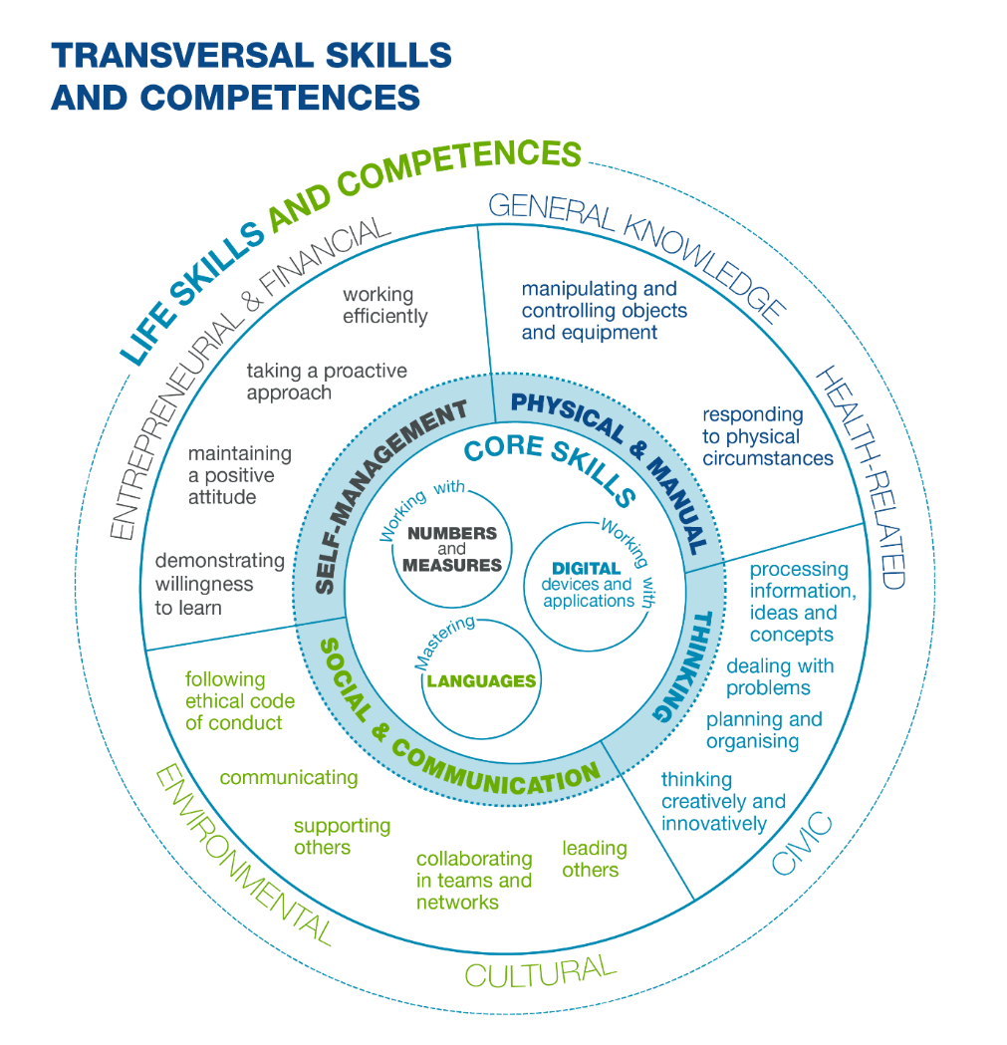

Source: ESCO/EQF TSC expert group, 2021

The approach can also be illustrated using a mind-map. The benefit by this form of visualization is that it allows for a detailed depiction of the relationships between categories, clusters and single terms. Figure 2 illustrates the complete model as presented by the expert group. Separate parts of this overall map will be used throughout the report to illustrate how the three levels of categories, clusters and single concepts are related.

Figure 2. The transversal skills and competence model - overview

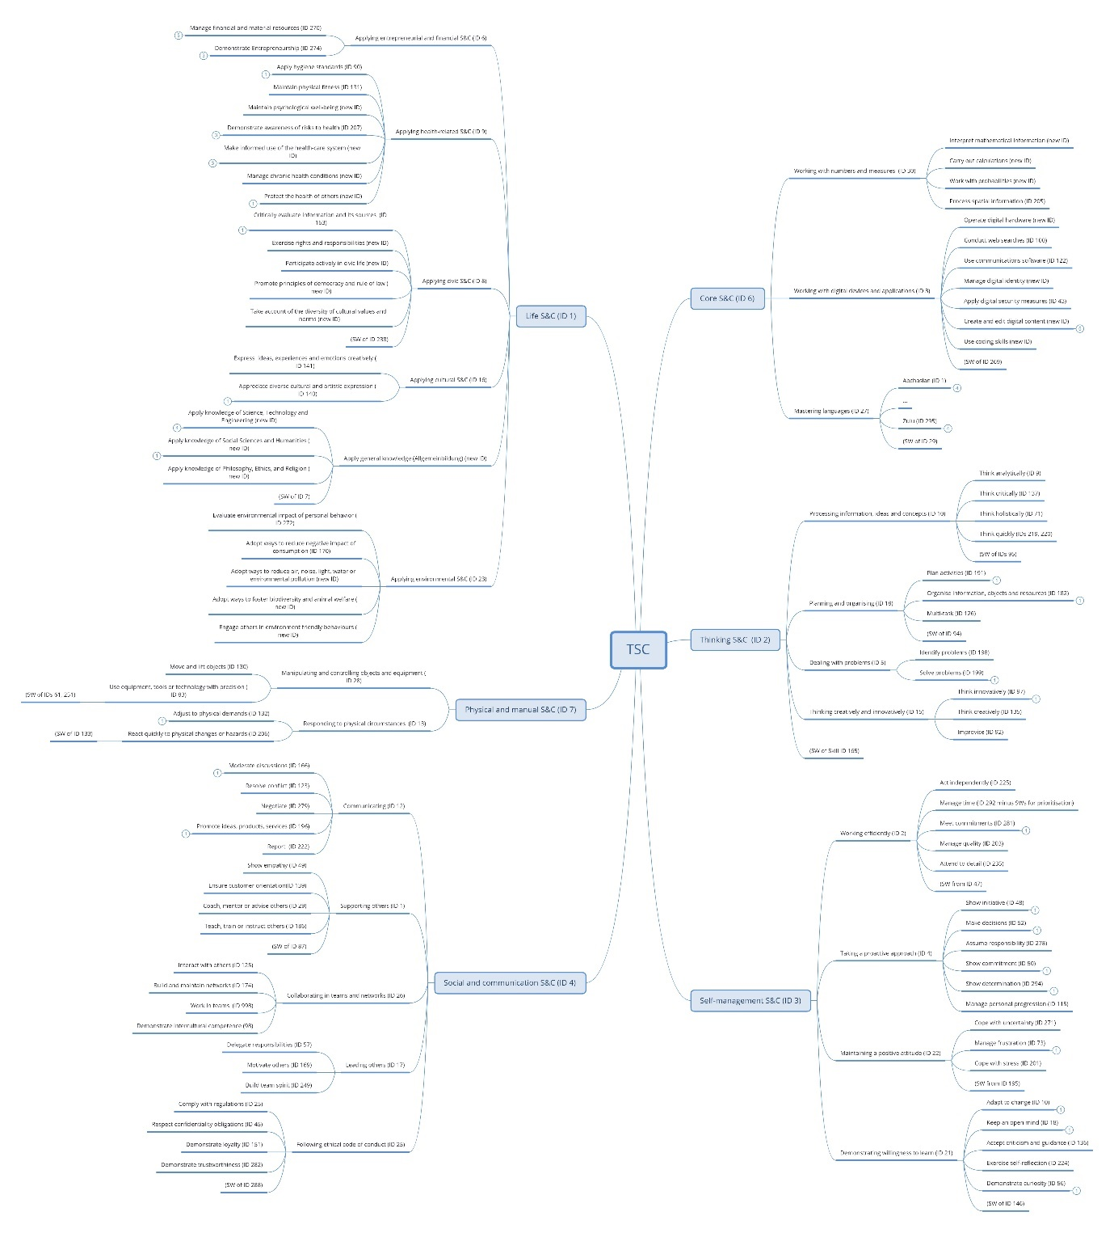

Source: ESCO/EQF TSC expert group, 2021

Skills and competence categories, clusters and single concepts

As indicated above, the model makes it possible for users to drill down from the broad categories (level 1) via the more detailed clusters (level 2) to the single concepts (Level 3). To indicate the orientation and scope of the terminology, definitions have been developed for the six main categories as well as for selected clusters. On a longer-term basis, it is recommended that definitions and scope notes are developed for all clusters and single terms included. The expert group, given limited time and resources, have not been able to complete all these tasks.
As illustrated by Annex I, the expert group has, from the sources consulted, identified more than 1400 single TSC terms distributed across the main 6 categories. The number of terms included in the final proposal has been radically reduced, reflecting the need to avoid unnecessary duplications and identify a set of key single concepts (preferred terms) eventually to be included by ESCO. This reduction in the number of preferred terms is important to ensure clarity and a wider use of the terminology. Combined with the extensive list of synonyms and alternative labels identified in the initial phase of the work, the model will hopefully make it possible for future users to better navigate in this complex terminological field.
The model uses verb phrasing throughout. The expert group agrees that this denotes agency and helps distinguish a skill or competence from an attitude, value, or personality type. The verb phrasing reiterates the group’s conclusion regarding the nature and scoping of transversal skills and competences included in this model; attitudes and values should only be included to the extent that they can be learned, developed and demonstrated.

Core skills and competences
The core skills and competences referred to under this heading provide a minimum basis for individual learning and interacting with others. The following sections outline the definition of the category, the identified clusters and the single concepts allocated to these clusters. Relationships to already existing terminological approaches are identified, and a final visualization shows the relationship between the terms and provides a link to sources.

5.1.1 Definition of Core skills
The definition of Core skills and competences draws on several sources, notably the EU Key Competences Framework, OECD PIAAC, the Common European Framework of Reference for Languages and the European Life Skills for Europe framework:
Core skills and competences refer to the ability to understand, speak, read and write language(s), to work with numbers and measures and use digital devices and applications. Core skills and competences represent the foundation for interacting with others and for developing and learning as an individual.

5.1.2 Core Skills clusters
With reference to already existing approaches in this area, we suggest operating with three distinct terminological clusters for core skills and competences:
- Mastering languages
- Working with numbers and measures
- Working with digital devices and applications ()

These three distinct clusters of core skills build on a range of existing approaches, illustrated by the OECD’s Program for the International Assessment of Adult Competencies (PIAAC) where Literacy, Numeracy and Problem Solving in Technology-Rich Environments have been defined as ‘foundation skills’(). These three core skills clusters also cover the transversal aspects of the first four of the eight EU ‘Key Competences’ () - Literacy competence, Multilingual competence, Mathematical competence and competence in science, technology and engineering, and Digital competence – thus reiterating their centrality to living, working, and navigating modern societies.

5.1.3 Single concepts illustrating core skills and competences
The single concepts related to languages build on the principles established by the Common European framework for languages (CEFR) () and should be consistent with the current integration of language skills and competences in ESCO.

Mastering Languages

- Abkhasian
- …
- …
- Zulu
The languages specified under this cluster refer to the single languages covered by ESCO v1.0. The level of mastery is then further drilled down into the four basic foundational language skills as specified by the CEFR, those being ‘understanding’, ‘reading’, ‘speaking’, and ‘writing’ a first or subsequent language.
Working with numbers and measures

- Interpret mathematical information
- Carry out calculations
- Work with probabilities
- Process spatial information

Working with digital devices and applications

- Operate digital hardware
- Conduct web searches
- Use communications software
- Manage digital identity
- Apply digital security measures
- Create and edit digital content
- Use coding skills

5.1.4 Sources and relationships
The core skills and competences build on already existing terminological approaches widely used for different purposes. Building on what is already in use and has been tested in various settings ensures continuity and overall quality. Given that the current model strives for overview, priority has been given to simplicity, not all detail has been kept. The following indicates the logic applied by the expert group.
Mastering languages: As for references to specific languages, the model refers to the list currently contained in ESCO version 1.0 (). When addressing the mastery of a language, the skills and competences, the four dimensions of the European Framework for Languages - speaking, understanding, reading and writing - are used. The expert group’s proposals build on the Common European Framework of Reference for Languages (CEFR). Social and interactional applications and use of language, such as advising, persuading and negotiating, are listed under Social and Communication skills and competences. Each language listed in ESCO would act as a separate cluster where the above four dimensions of skills and competence become apparent.
Working with numbers and measures: This cluster has been inspired by the Life Skills for Europe (LSE) framework, specifically the ‘personal empowerment’ skills of the ‘Numeracy Capability’ section (). It also integrates terms identified by the Recommendation Key Competences on mathematical competence (). A number of terms already included in ESCO version 1.0 under ‘Numeracy and Mathematics’ have also been taken into account ().
Working with digital devices and applications: This cluster captures basic digital skills and competences becoming increasingly critical for individuals to master. The proposal builds on the DigCOMP 2.1 framework, notably proficiency levels 1 and 2 (‘Foundation’) of (). The more advanced levels of DigiComp (3-8) (referring to ‘digital literacy’, ‘information and data literacy’, or ‘media literacy’), have been incorporated into the life skills and competences category. The proposal is also inspired by the Key Competences Framework () on digital competence and the Life Skills for Europe Framework (). In the same way as for DigiComp, some of the more specialised digital skills and competences referred to by the LSE are incorporated in the Life Skills and Competences category.
The core skills and competences, as is also the case for the entire TSC model, can be illustrated by using a mind map. While showing the relationships between the terms it also contains the links to the underpinning sources (Annex I).

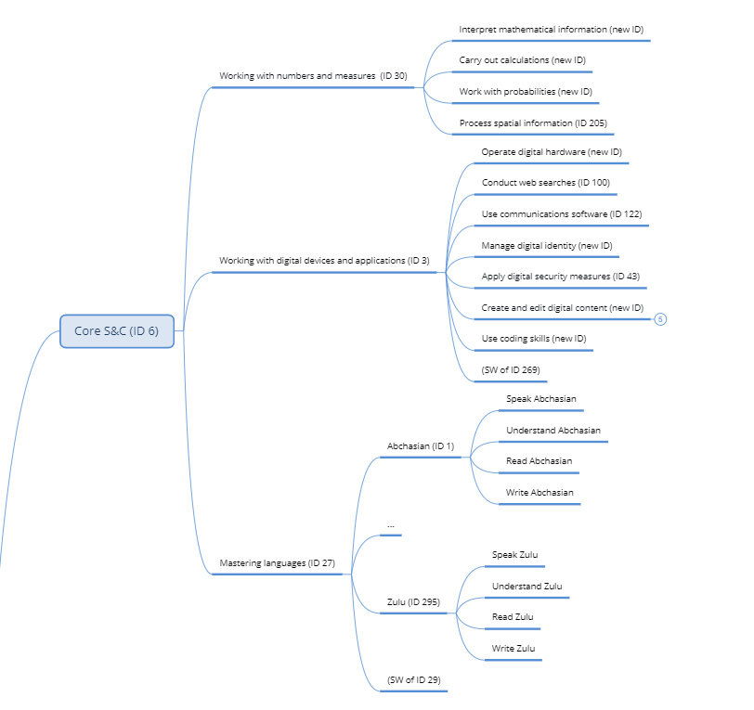

5.2 Thinking Skills and Competences
The thinking skills and competences referred to under this heading cover the ability to deal with abstract, cognitive concepts. The following sections outline the definition of the category, the identified clusters and the single concepts allocated to these clusters. Relationships to already existing terminological approaches, specifically ESCO (^{ESCO}), are identified. A final visualization shows the relationship between the terms and provides a link to sources.

5.2.1 Definition of Thinking skills and competences
Thinking (frequently referred to as cognitive) skills and competences allow the individual to deal with abstract cognitive concepts. The expert group suggests the following definition:
Thinking (cognitive) skills and competences relate to the ability to apply the mental processes of gathering, conceptualizing, analyzing, synthesizing, and/or evaluating information gathered from, or generated by, observation, experience, reflection, reasoning, or communication. This is demonstrated by using information of different kinds to plan activities, achieve goals, solve problems, deal with issues and perform complex tasks in routine and novel ways.

5.2.2 Thinking Skills and competences clusters
With reference to already existing approaches in this area, the expert group suggests operating with the following four clusters for thinking skills and competences:
- Processing information, ideas and concepts
- Planning and organising
- Dealing with problems
- Thinking creatively and innovatively

5.2.3 Single concepts illustrating thinking skills and competences
The following single concepts illustrate the orientation of these clusters.

Processing information, ideas and concepts

- Think analytically ^{ESCO}
- Think critically
- Think holistically
- Think quickly

Planning and organising

- Plan activities ^{ESCO ()}
- Organise information, objects and resources ^{ESCO ()}
- Multi-task

Dealing with problems

- Identify problems
- Solve problems

Thinking creatively and innovatively

- Think innovatively
- Think creatively ^{ESCO}
- Improvise

5.2.4 Relationships and sources
Existing single skills concepts, where possible, have been referenced to ESCO and been marked as such (^{ESCO}). In ESCO v1.0.8., these may appear under transversal skills/competences or as cross-sector skills and competences or have been identified as transversal by the expert group.
The Thinking skills and competences, as is also the case for the entire TSC model, can be illustrated by using a mind map. While showing the relationships between the terms it also contains the links to the underpinning sources used by the expert group (Annex 1).

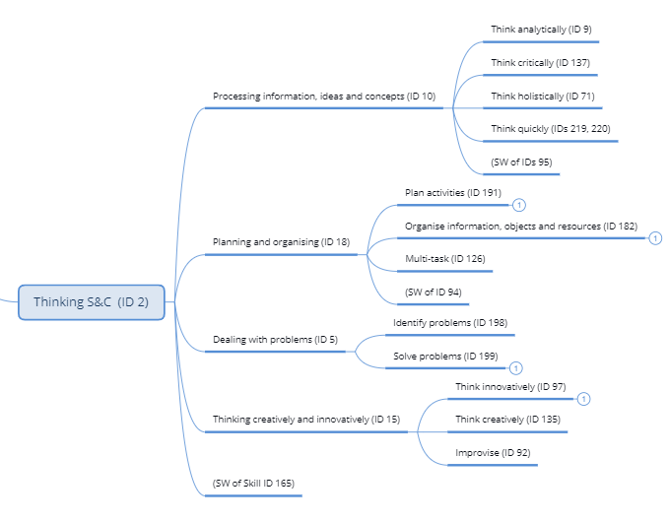

5.3 Self-management Skills and Competences
The self-management skills and competences point to the ability of individuals to make use of own potential. The following sections present the definition of the category, the identified clusters and the single concepts allocated to these clusters. Relationships to already existing terms in ESCO (^{ESCO}) are identified. A final visualization shows the relationship between the terms and provides a link to sources.

5.3.1 Definition of self-management skills and competences
Self-management skills allow the individual to reflect on and make best use of his/her own abilities and potential:
The skills and competences referred to under this heading require the individual to understand and control their own strengths and limitations and use this self-awareness to manage activities in a variety of contexts. This is demonstrated by an ability to act reflectively, responsibly and in ways which are structured according to values, by accepting feedback, and by seeking opportunities for personal and professional development.

5.3.2 Self-management skills and competences clusters
With reference to already existing approaches in this area, the expert group suggests operating with the following four clusters for thinking skills and competences:
- Working efficiently ^{ESCO}
- Taking a proactive approach
- Maintaining a positive attitude
- Demonstrating willingness to learn ^{ESCO}

5.3.3 Single concepts illustrating self-management skills and competences
The single concepts listed in the following illustrate the orientation of these clusters.

Working efficiently

- Act independently ^{ESCO}
- Manage time ^{ESCO}
- Meet commitments ^{ESCO}
- Manage quality ^{ESCO}
- Attend to detail ^{ESCO}

Taking a proactive approach

- Show initiative
- Make decisions ^{ESCO}
- Assume responsibility
- Show commitment
- Show determination
- Manage personal progression

Maintaining a positive attitude

- Cope with uncertainty ^{ESCO ()}
- Manage frustration ^{ESCO}
- Cope with stress ^{ESCO}

Demonstrating willingness to learn

- Adapt to change ^{ESCO}
- Keep an open mind
- Accept criticism and guidance
- Exercise self-reflection
- Demonstrate curiosity ^{ESCO}

5.3.4 Relationships and sources
Existing single skills concepts, where possible, have been referenced to ESCO and been marked as such (^{ESCO}). In ESCO v1.0.8., these may appear under transversal skills/competences or as cross-sector skills and competences or have been identified as transversal by the expert group.
The self-management skills and competences, as is also the case for the entire TSC model, can be illustrated by using a mind map. While showing the relationships between the terms it also contains the links to the underpinning sources used by the expert group.

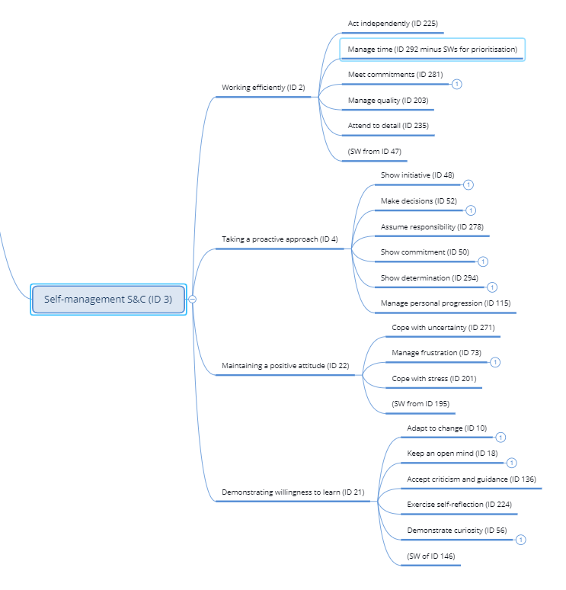

5.4 Social and Communication Skills and Competences
While previous categories focus on the ‘internal’ abilities and capabilities of individuals, social and communication skills and competences focus on the interaction between individuals in social contexts. This category lies at the heart of many existing efforts to define transversal skills and competences, typically identified through headline terms like ‘soft skills’ and ‘non-cognitive’ skills.

5.4.1 Definition of social and communication skills and competences
Social and communication skills and competences allow the individual to interact with other people and are defined as follows:
The skills and competences referred to under this heading relate to the ability to interact positively and productively with others. This is demonstrated by communicating ideas effectively and empathetically, coordinating one’s own objectives and actions with those of others, seeking resolutions to differences, building trust and settling conflicts, ensuring the well-being and progress of others, managing activities and offering leadership.

5.4.2 Social and communication skills and competences clusters
With reference to already existing approaches in this area, the expert group suggests operating with the following five clusters for social and communication skills and competences:
- Communicating
- Supporting others
- Collaborating in teams and network
- Leading others ^{ESCO}
- Following ethical code of conduct ^{ESCO}

5.4.3 Single concepts illustrating social and communication skills and competences
The single concepts listed in the following illustrate the orientation of the clusters.

Communicating

- Moderate discussions
- Resolve conflict ^{ESCO ()}
- Negotiate
- Promote ideas, products, services
- Report

Supporting others

- Show empathy
- Ensure customer orientation
- Couch, mentor or advise others
- Teach, train or instruct others

Collaborating in teams and networks

- Interact with others ^{ESCO}
- Build and maintain networks ^{ESCO ()}
- Work in teams ^{ESCO}
- Demonstrate intercultural competence ^{ESCO}

Leading others ^{ESCO}

- Delegate responsibilities
- Motivate others ^{ESCO}
- Build team spirit

Following ethical code of conduct ^{ESCO}
- Comply with regulations
- Respect confidentiality obligations
- Demonstrate loyalty
- Demonstrate trustworthiness

5.4.4 Relationships and sources
Existing single skills concepts, where possible, have been referenced to ESCO and been marked as such (^{ESCO}). In ESCO v1.0.8., these may appear under transversal skills/competences or as cross-sector skills and competences or have been identified as transversal by the expert group.
The social and communication skills and competences, as is also the case for the entire TSC model, can be illustrated by using a mind map. While showing the relationships between the terms it also contains the links to the underpinning sources used by the expert group.

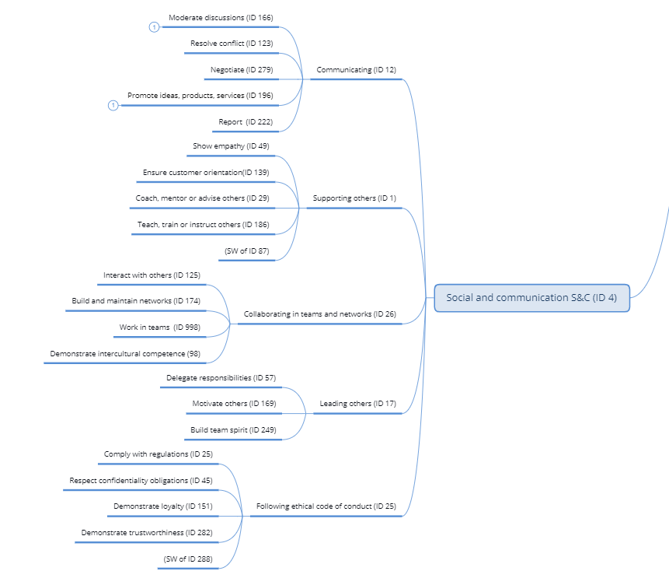

5.5 Physical and manual skills and competences
The inclusion of physical and manual skills in the terminology can, from some perspectives, be problematic. Not all physical and manual abilities can be controlled or changed by the individual and may thus result in unfair treatment or discrimination. However, some physical and manual abilities can be learned and improved and are of key importance in private as well as professional life. The terms included here refer to this latter type.
Existing single skills concepts, where possible, have been referenced to ESCO and been marked as such (^{ESCO}). In ESCO v1.0.8., these may appear under transversal skills/competences or as cross-sector skills and competences or have been identified as transversal by the expert group.

5.5.1 Definition of physical and manual skills and competences
Being in possession of physical and manual skills and competences allows the individual to master tasks and activities which require some form of manual or other physical input:
Referred to under this heading is the ability to perform tasks and activities which require manual dexterity, agility and/or bodily strength. They may be carried out in demanding or hazardous environments requiring endurance or stamina. These tasks and activities may be carried out by hand, with other direct physical intervention, or by using equipment, tools or technology which requires guidance, movement or force, such as ICT devices, machinery, craft or musical instruments.

5.5.2 Physical and manual skills and competences clusters
With reference to already existing approaches in this area, the expert group suggests operating with the following two clusters for physical and manual skills and competences:
- Manipulating and controlling objects and equipment
- Responding to physical circumstances

5.5.3 Single concepts illustrating physical and manual skills and competences
The single concepts listed in the following illustrate the orientation of the clusters.

Manipulating and controlling objects and equipment

- Move and lift objects ^{ESCO ()}
- Use equipment, tools or technology with precision ^{ESCO ()}

Responding to physical circumstances

- Adjust to physical demands
- React quickly to physical changes or hazards

5.4.4 Relationships and sources
The physical and manual skills and competences, as is also the case for the entire TSC model, can be illustrated by using a mind map. While showing the relationships between the terms it also contains the links to the underpinning sources used by the expert group.

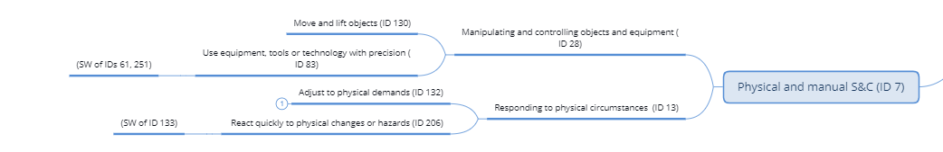

5.6 Life Skills and Competences
The life skills and competences allow individuals to deal with the conditions and responsibilities of modern life. Compared to the five other categories identified above, life skills and competences reflect changing societies and will to some extent be more dynamic and subject to change than the previous categories. Acknowledging the character of these skills and competences, the expert group have included definitions of the overall category as well as the separate clusters covered.

5.6.1 The definition of life skills and competences
Life skills and competences allow the individual to deal with the conditions and responsibilities of life in modern society:

The skills and competences referred to under this heading relate to the ability to process and use knowledge and information which has transversal significance and facilitates active citizenship. They cover aspects such as health, culture, finance and economics, science and technology, the environment and civic engagement. Life skills and competences allow individuals to manage knowledge and information and use it as a basis for forming opinions, making decisions and taking actions in relation to both personal/professional progression and social responsibility.

5.6.2 Life skills and competences clusters
The expert group recommends including the following clusters in the life skills and competence category.
- Applying entrepreneurial and financial skills and competences
- Applying health-related skills and competences
- Applying cultural skills and competences
- Applying civic skills and competences
- Applying general knowledge
- Applying environmental skills and competences

As addressed in the section on Core skills and competences, it is worth noting that some of the clusters of the Life skills and competences category also partly overlap with the EU key-competences framework and its categories ‘Digital competence’, ‘Citizenship competence’, ‘Entrepreneurship competence’ and ‘Cultural awareness and expression competence’. Given the efforts invested in the Key Competences framework, the expert group sees it as important to build on the basis already established. While core skills and competences are key to navigating modern societies, the Life skills and competences expand on the basis established in the first category and can be seen as skills and competences allowing an individual to thrive and participate actively and fully in society.
The fact that Environmental literacy and Health literacy are not covered by the key competences framework illustrates that the category ‘Life skills and competences’, as suggested in this report, is continuously evolving and responds to contextual and external factors. While the categories on Thinking, Self-Management, Social/Communication skills – these covering the ‘Personal, social and learning to learn competence’ of the key competence framework – as well as the Physical/Manual skills and competences will remain (fairly) stable, the terminology related to the Life skills and competences clusters will change and develop.

Using the mind map, this category is defined as follows:

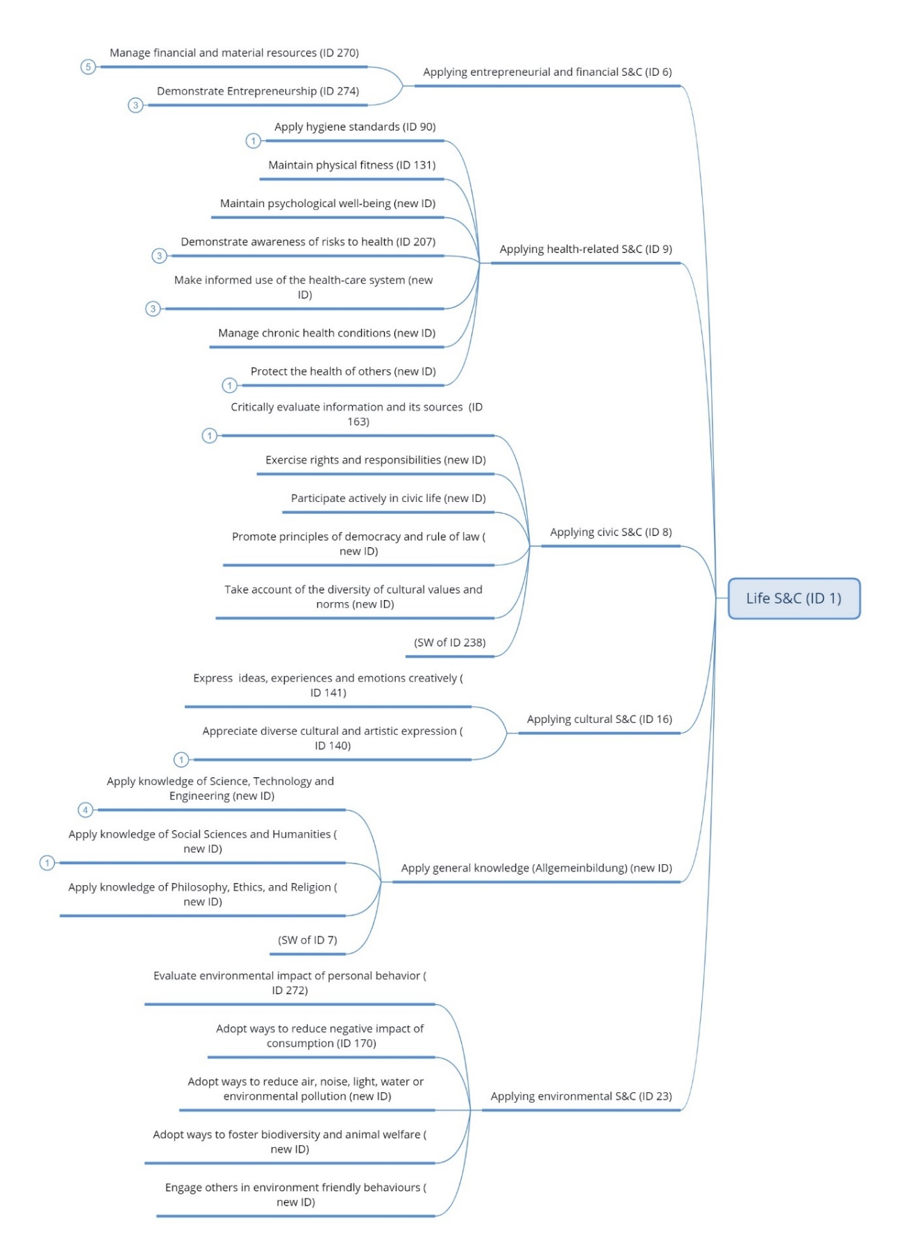

This is based on the definitions and single concepts presented in the sections below.

5.6.3 Applying entrepreneurial and financial skills and competences

The expert group defines this life skills cluster in the following way:

The skills and competences referred to under this heading address the ability to manage (own and others) finances and resources, to plan and to recognise financial rights, duties and risks. Entrepreneurial skills and competences are based on the above, but also include perseverance, openness to opportunity and risk, the ability to mobilize resources and willingness to learn from experience.

The following single skills and concepts capture the orientation of this cluster:

- Manage financial and material resources
- Demonstrate entrepreneurship

5.6.4 Applying health related skills and competences
The expert group defines health related skills and competences in the following way:

The skills and competences under this heading address the ability to care for own and others’ mental and physical well-being. This includes the ability to obtain and use health information; to apply basic health standards, including hygiene; identify and access services and agencies that offer healthcare and guidance; and manage the negative effects of chronic health conditions.
The following single concepts have been identified to capture the orientation of this cluster:
- Apply hygiene standards
- Maintain physical fitness
- Maintain psychological well-being
- Demonstrate awareness of risks to health
- Make informed use of the health-care system
- Manage chronic health conditions
- Protect the health of others

5.6.5 Applying cultural skills and competences
The expert group defines cultural skills and competences the following way:

The skills and competences under this heading address the ability to express and interpret ideas, experiences and emotions creatively. These skills and competences also imply openness to learning from different cultural and artistic expressions. Creativity and respecting diversity underpin the skills and competences under this heading.
The following single concepts have been identified to capture the orientation of this cluster:
- Express ideas, experiences and emotions creatively
- Appreciate diverse cultural and artistic expression

5.6.6 Applying civic skills and competences
The expert group defines civic skills and competences the following way:

The skills and competences referred to under this heading address the ability to actively interact with fellow citizens and engage in communities. This requires the ability to evaluate information and its sources; reflect on own ideas, values and roles; and recognize and respect those (ideas, values and roles) of others.

The following single concepts have been identified to capture the orientation of this cluster :
- Critically evaluate information and its sources
- Exercise rights and responsibilities
- Participate effectively in civic life
- Promote principles of democracy and rule of law
- Take account of the diversity of cultural values and norms

5.6.7 Applying general knowledge

The expert group defines general knowledge the following way:

These skills and competences allow individuals to access and apply basic knowledge related to science, technology and engineering; to social sciences and humanities; and to philosophy, ethics and religion. While the skills and competences covered underneath this heading capture what is often referred to as general general education in country-specific contexts (‘Allgemeinbildung’), they can be acquired either as part of a formal qualification or in non-formal and informal settings.

The following single concepts have been identified to capture the orientation of this cluster:
- Apply knowledge of Science, Technology, and Engineering
- Apply knowledge of Social Sciences and Humanities
- Apply knowledge of Philosophy, Ethics, and Religion

5.6.8 Applying environmental skills and competences
The expert group defines environmental skills and competences the following way:

The skills and competences referred to under this heading include the following: the ability to reflect the short- and long-term impact of individual behaviour on the physical and social environment; the motivation and capacity to adopt a sustainable work- and lifestyle for oneself; and the capacity to inspire it in others. This implies the ability to recognize the individual and collective responsibility for the protection and restoration of the local and global environment. The skills and competences under this heading address the different modes and activities relevant for a greener working and living. A holistic perspective, an ethical code, consideration for others and the ability to behave in accordance with these underpin the skills and competences.

The following single concepts have been identified to capture the orientation of this cluster :
- Evaluate environmental impact of personal behaviour
- Adopt ways to reduce the negative impact of consumption
- Adopt ways to reduce air, noise, light, water or environmental pollution
- Adopt ways to foster biodiversity and animal welfare
- Engage others in environmentally friendly behaviours

Concluding remarks
This report, based on an extensive analysis of existing sources and applications, captures the characteristics and scope of transversal skills and competences and indicates how different terms interact and can be related. The proposal will make it possible for ESCO to better capture the changing balancing of transversal and occupationally specific skills and competences characterizing modern labour markets and education and training systems. It should be underlined that the intention behind this work has not been to replace existing approaches in this area; many of which play important roles in informing policies and practices. The purpose has rather been to develop a comprehensive model making it possible to contextualize existing approaches and inspire and inform new ones. In agreement with the Commission, the proposal will be further developed in two important ways:
- The detailed terminological basis of the model will be further elaborated to make it possible to identify sources and document the deliberations of the expert group. This work will give access to the rich diversity of synonyms existing for each preferred term, potentially to be used as a source by future users of the terminology.
- An extended version of the report will be published by Cedefop and the Commission. This report will provide a model detailed conceptual discussion and include the technical annex referred to above. This report will furthermore include a section on possible use-areas for the terminology; how it can support both education and training and labour market stakeholders.

Selected sources used by the expert group

Ajraoui, Kaddour, Zeriouh (2019). Transversal Skills in Vocational Education and Training: The Case of ENSAM Engineering Students, European Scientific Journal, March 2019 edition Vol. 15, No 8.
Ananiadou, K., and Claro, M. (2009). 21st century skills and competences for new millennium learners in OECD countries. Paris: OECD.
Anderson, L.W., Krathwohl, D.R., Airasian, P.W., Cruikshank, K.A., Mayer, R.A., Pintrich, P.R., Raths, J., and Wittrock, M.C. (2001). A taxonomy for learning, teaching, and assessing: A revision of Bloom’s taxonomy of educational objectives. Boston, MA: Allyn & Bacon.
Atenas, J., Havemann, L. & Priego, E. (2015). Open Data as Open Educational Resources: Towards Transversal Skills and Global Citizenship. Open Praxis, 7(4), 377-389. International Council for Open and Distance Education.
Bertelsmann Stiftung (2018). Competence Cards for Immigration Counselling. Güterloh: Verlag Bertelsmann Stiftung.
Bertelsmannstiftung (2021): Kompetenzkarten der Bertelsmannstiftung. https://www.bertelsmann-stiftung.de/de/unsere-projekte/aufstieg-durch-kompetenzen/projektthemen/kompetenz-und-berufekarten-neu (Last accessed 02.06.2021)
Bundesministerium für Bildung und Forschung (2013). Deutscher Qualifikationsrahmen für Lebenslanges Lernen: German EQF Referencing. Available at https://ec.europa.eu/ploteus/en/referencing-reports-and-contacts (Last accessed 07.12.19)
Carretero Gomez, S., Vuorikari, R. and Punie, Y. (2017): DigComp 2.1: The Digital Competence Framework for Citizens with eight proficiency levels and examples of use, EUR 28558 EN, Publications Office of the European Union, Luxembourg, ISBN 978-92-79-68006-9 (pdf).
Cedefop (2008). Terminology of European Education and Training Policy: a selection of 100 key terms (Luxembourg). Available at https://www.cedefop.europa.eu/files/4064_en.pdf [last accessed 29.12.19]
Cedefop (2017), Defining, writing and applying learning outcomes: A European Handbook https://www.cedefop.europa.eu/en/publications-and-resources/publications/4156
Cedefop (2018), Analysis and overview of NQF level descriptors in European countries https://www.cedefop.europa.eu/en/publications-and-resources/publications/5566
CEDEFOP (2019) EQF AG Note Meetings of the EQF Advisory Group and ESCO Member States Working Group, 5-6-7 February 2019, Note JAG 2-3, The need for an agreed terminology on transversal skills and competences, European Commission and CEDEFOP, 2019.
Cedefop (2019). Skills Panorama. Online at https://skillspanorama.cedefop.europa.eu/en/glossary [last accessed 29.12.19]
Council of Europe (2001): Common European Framework of References for Languages. https://www.coe.int/en/web/common-european-framework-reference-languages (Last accessed 04.06.2021)

Council of the European Union (2017). Council Recommendation of 22 May 2017 on the European Qualifications Framework for lifelong learning and repealing the recommendation of the European Parliament and of the Council of 23 April 2008 on the establishment of the European Qualifications Framework for lifelong learning. Available at https://publications.europa.eu/en/publication-detail/-/publication/ceead970-518f-11e7-a5ca-01aa75ed71a1/language-en (Last accessed 10.04.18)
Council of the European Union (2018). Council Recommendation of 22 May 2018 on key competences for lifelong learning. Available at https://eur-lex.europa.eu/legal-content/EN/TXT/?uri=uriserv:OJ.C_.2018.189.01.0001.01.ENG&toc=OJ:C:2018:189:TOC (Last accessed 29.12.19)
Delamare-Le Deist, F. and Winterton, J. (2005). What is competences? Human Resource Development International, Vol. 8, No. 1, 27 – 46, March 2005.
EAEA (2018). Life Skills for Europe (LSE) Framework. https://eaea.org/project/life-skills-for-europe-lse/ (Last accessed 04.06.2021)
European Commission (2008) The European Framework for Lifelong Learning (EQF). Available at https://ec.europa.eu/ploteus/documentation (Last accessed 09.06. 16).
European Commission. (2018). ESCOpedia. Online at https://ec.europa.eu/esco/portal/escopedia/European_Skills_44__Competences_44__Qualifications_and_Occupations__40_ESCO_41_ (Last accessed 27.10.19)
European Commission (2019a). What is ESCO? Online at https://ec.europa.eu/esco/portal/howtouse/21da6a9a-02d1-4533-8057-dea0a824a17a (Last accessed 30.10.19)
European Commission (2019b). ESCO Handbook: European Skills, Competences, Qualifications and Occupations. Available at https://ec.europa.eu/esco/portal/document/en/0a89839c-098d-4e34-846c-54cbd5684d24 (Last accessed 20.10.19)
European Commission (undated). ESCO Service Platform Data Model. Available at https://ec.europa.eu/esco/portal/document/en/87a9f66a-1830-4c93-94f0-5daa5e00507e (Last accessed 20.10.19)
European Economic and Social Committee (2012). Active Citizenship for a better European Society. Brussels: EESC Visits and Publications Unit. Available at https://www.eesc.europa.eu/resources/docs/eesc-2011-35-en.pdf (Last accessed 06.08.14)
French Working Group (2010). Referencing of the French National Framework of Qualifications (NFQ) in the light of the European Qualifications Framework for Lifelong Learning. Paris: Commission Nationale de la Certification Professionelle. Available at https://ec.europa.eu/ploteus/en/referencing-reports-and-contacts (last accessed 07.12.19)
Gretter S. & Yadav A. (2016). Computational Thinking and Media & Information Literacy: An Integrated Approach to Teaching Twenty-First Century Skills. Tech Trends, Springer, 60. 510–516.
Halpern, Diane F. (2006). The Nature and Nurture of Critical Thinking. Critical Thinking in Psychology, Cambridge University Press, pp. 1–14, ISBN 9780511804632
Hernstein, R.J., Nickerson, R.S., Sanchez, M., and Swets, J.A. (1986). Teaching thinking skills. American Psychologist, 41, 1,279-1,289.
Ipate, D., M., Mitran, P., C., Parvu, I. (2014). Identification of Employability Skills - Starting Point for the Curriculum Design Process, Economics, Management and Financial Markets
Joint Research Center (JRC) (2019): The European Entrepreneurship Competence Framework (EntreComp). https://ec.europa.eu/social/main.jsp?catId=738&langId=en&pubId=8201&furtherPubs=yes (Last accessed 02.06.2021)

Joint Research Center (JRC) (2020) : LifeComp: The European Framework for Personal, Social and Learning to Learn Key Competence. https://publications.jrc.ec.europa.eu/repository/bitstream/JRC120911/lcreport_290620-online.pdf (Last accessed 04.06.2021)
Lamback, S., Gerwin, C. and Restuccia, D. (2018). When is a job just a job —and when can it launch a career? The real economic opportunities of middle-skill work. Boston: JFF.
Langa, C. (2015). The contribution of transversal competences to the training of the educational sciences specialist. Procedia-Social and Behavioural Sciences, 180, 7-12.
Larraz, N., Vázquez, S. and Liesa, M. (2017). Transversal skills development through cooperative learning. Training teachers for the future, On the Horizon, Vol. 25 No. 2, pp. 85-95.
Lindqvist, E., and Vestman, R. (2011). The labor market returns to cognitive and noncognitive ability: Evidence from the Swedish enlistment. American Economic Journal: Applied Economics, 3, 101-128.
Lippman, L. et al. (2015), Key Soft Skills that Foster Youth Workforce Success; Toward a Consensus Across Fields. Child Trends Publishing, Washington, DC. Available at https://www.childtrends.org/wp-content/uploads/2015/06/2015- 24WFCSoftSkills1.pdf (Last accessed 31.12,19).
Logai, V., et al (2014). Referencing the Slovenian Qualifications Framework to the European Qualifications Framework for Lifelong Learning and the Qualifications Framework for the European Higher Education Area: Final Report. Ljubljana: Institute of the Republic of Slovenia for Vocational Education and Training (CPI). Available at https://ec.europa.eu/ploteus/sites/eac-eqf/files/Final%20Report%20SI_2014.pdf (Last accessed 13.10.17)
Martin, J. P. (2018). Skills for the 21st Century: Findings and Policy Lessons from the OECD Survey of Adult Skills. OECD Education Working Paper No, 166. OECD Publishing, Paris. Available at http://www.oecd.org/officialdocuments/publicdisplaydocumentpdf/?cote=EDU/WKP(2018)2&docLanguage=En (Last accessed 31.12.19)
National Research Council (2012): Education for Life and Work: Developing Transferable Knowledge and Skills in the 21st Century. Washington, DC: The National Academies Press. https://doi.org/10.17226/13398. (Last accessed 04.06.2021)
OECD (2014). Competency Framework, Available at https://www.oecd.org/careers/competency_framework_en.pdf (Last accessed 30.12.19)
OECD (2012). Literacy, Numeracy and Problem Solving in Technology-Rich Environments: Framework for the OECD Survey of Adult Skills, OECD Publishing. http://dx.doi.org/10.1787/9789264128859-en (Last accessed 04.06.2021)

PwC, Tipik, 3s, FGB (2016). ESCO Terminological Guidelines v1: General section. Update of September 23. 2016
PwC, Tipik, 3s, FGB (2016). Language-specific rules for English.
Republica Italiana (2012). First Italian Referencing Report to the European Qualifications Framework – EQF. Available at https://ec.europa.eu/ploteus/en/referencing-reports-and-contacts (last accessed 07.12.19)
UNESCO/UIL, ETF, Cedefop (2019) Global Inventory of Regional and National Qualifications Frameworks, Volume II: National and Regional Cases. Hamburg: UNESCO. https://www.cedefop.europa.eu/files/2225_en.pdf [Last accessed 09.10.19]

UNESCO-International Bureau of Education (2007). The UNESCO-IBE Education Thesaurus, sixth ed., 2nd rev. Available at http://www.ibe.unesco.org/en/unesco-ibe-education-thesaurus (Last accessed 18.11.19)
UNESCO-UNEVOC. (2014). TVETipedia Glossary. Online at https://unevoc.unesco.org/go.php?q=TVETipedia+Glossary+A-Z&id=577 (Last accessed 27.10.19)
Wikipedia: Big Five Personality Traits. Online at https://en.wikipedia.org/wiki/Big_Five_personality_traits (Last accessed 06.01.20)
Wikipedia: HEXACO model of personality structure. Online at https://en.wikipedia.org/wiki/HEXACO_model_of_personality_structure (Last accessed 06.01.20)
World Skills (2021). WorldSkills Occupational Standards Specification. Online at https://worldskills.org/what/projects/wsss/

() Supported by (2021) Michaela Hermann and (2019-20) Katerina Antoniadi, both trainees at Cedefop
() The sources used and analyzed by the expert group are published in a separate technical annex.
() ESCO version 1.0 refers to these as ‘cross sectoral skills and competences’.
() Working paper 1 and 2 of the expert group, July and October 2020, discusses these principles in more detail and can be consulted separately.
() The distinction between skills and competences is discussed in detail in reports 1 and 2 of the Expert group
() The relationship between these alternative headlines are discussed in detail in reports 1 and 2 of the Expert group.
() The expert group has discussed the issue of ‘levelling’, i.e. the (ideal) need to express different levels of complexity of terms. This is an issue outside the mandate of the group but should be given due attention in future updates of ESCO. The expert group also noted the efforts done by the 2012-15 cross sectoral working group and recommend building on this. Reflecting this restricted mandate, the expert group has refrained from using terms signaling complexity or expertise (such as “simple” or “according to requirements.
National Research Council (2012): Education for Life and Work: Developing Transferable Knowledge and Skills in the 21st Century. Washington, DC: The National Academies Press. <https://doi.org/10.17226/13398.>
() Cluster headings will use the progressive -ing to denote the active voice, whereas single skills concepts use the verb’s infinitive. This is in line with ESCO guidelines.
The expert group has located working with digital devices as a cluster under Core skills and competences, reflecting their increasing centrality in all contexts of life. This represents a change from the preliminary proposal of the group where transversal digital skills were located to the Life Skills category.
OECD (2012). Literacy, Numeracy and Problem Solving in Technology-Rich Environments: Framework for the OECD Survey of Adult Skills, OECD Publishing. <http://dx.doi.org/10.1787/9789264128859-en>
Council of the European Union (2018): Council Recommendation of 22 May 2018 on Key Competences for Lifelong Learning (Text with EEA relevance). 2018/C 189/01. Annex. < https://eur-lex.europa.eu/legal-content/EN/TXT/PDF/?uri=CELEX:32018H0604(01)&from=EN>
() Council of Europe CEFR: https://www.coe.int/en/web/common-european-framework-reference-languages/level-descriptions
() EC, DG EMPL (2020): European Skills, Competences, Qualifications and Occupations. <https://ec.europa.eu/esco/portal>
() Council of Europe (2001): Common European Framework of References for Languages. <https://www.coe.int/en/web/common-european-framework-reference-languages>
() EAEA (2018). Life Skills for Europe (LSE) Framework. <https://eaea.org/project/life-skills-for-europe-lse/>
() Official Journal of the European Union (2018): Council Recommendation of 22 May 2018 on Key Competences for Lifelong Learning (Text with EEA relevance). 2018/C 189/01. Annex. < https://eur-lex.europa.eu/legal-content/EN/TXT/PDF/?uri=CELEX:32018H0604(01)&from=EN>
() Changes from current ESCO formulations have been implemented where appropriate (e.g., ‘carry out work-related calculations’ has, due to the nature of the model, been reformulated to ‘carry out calculations’: ‘work with shape and space’ has been reformulated to ‘process spatial information’).
() Carretero Gomez, S., Vuorikari, R. and Punie, Y. (2017): DigComp 2.1: The Digital Competence Framework for Citizens with eight proficiency levels and examples of use, EUR 28558 EN, Publications Office of the European Union, Luxembourg, ISBN 978-92-79-68006-9 (pdf).
() Official Journal of the European Union (2018): Council Recommendation of 22 May 2018 on Key Competences for Lifelong Learning (Text with EEA relevance). 2018/C 189/01. Annex. < https://eur-lex.europa.eu/legal-content/EN/TXT/PDF/?uri=CELEX:32018H0604(01)&from=EN>
() EAEA (2018). Life Skills for Europe (LSE) Framework. <https://eaea.org/project/life-skills-for-europe-lse/>
() Generalized from various cross-sector and sector specific formulations, as well as ‘planning and scheduling events and activities’.
() Merged various skills such as ‘apply conceptual thinking’, ‘structure information’, ‘store information’, and ‘organize information’.
Rephrased from ‘deal with uncertainty’.
Rephrased existing concept ‘handle conflicts’.
Rephrased from existing concept ‘liaising and networking’.
Rephrased and merged existing skills concepts ‘handling and moving’, ‘move and lift’ and ‘positioning materials, tools, or equipment’.
Rephrased and merged existing skills concepts ‘using hand tools’, ‘positioning materials, tools, or equipment’ and ‘working with machinery and specialized equipment’.
Council of the European Union (2018): Council Recommendation of 22 May 2018 on Key Competences for Lifelong Learning (Text with EEA relevance). 2018/C 189/01. Annex.
This cluster builds on The European Entrepreneurship Competence Framework. Joint Research Center (JRC) (2019): The European Entrepreneurship Competence Framework (EntreComp). <https://ec.europa.eu/social/main.jsp?catId=738&langId=en&pubId=8201&furtherPubs=yes>
This cluster references some of the single skills concepts identified under ‘health capability’ in the LSE framework.
This cluster references some of the ‘relationships with others & local community’ and ‘active engagement’ skills concepts identified under ‘civic capability’ in the LSE framework.
This clusters builds on the ‘environmental capability’ category of the LSE framework.

