ESCO implementation in EURES: state of play
MSWG 15-03 | MAI 36-03

29 November 2021

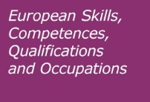

Background
ESCO was, inter alia, developed to support the automated skills-based matching of the EURES service platform. In 2016 the EURES Regulation aiming to put in place better job search and recruitment services across Europe was adopted. Article 19 of the EURES Regulation and its Implementing Decisions - adopted by the European Commission on 18 July 2018 - provide for the use of a European classification of skills, competences and occupations (ESCO) in an automated skills-based matching tool through the EURES portal.

To enable successful implementation, Member States need to supply job vacancies and CVs using ESCO codes, defining occupations and skills. To this end, Member States had until August 2021 to map their national occupational classifications and national skills classifications to ESCO. Alternatively, they could decide to directly adopt ESCO.

State of play
The deadline for a. the submission of mapping tables between ESCO and national classifications of occupations/skills or the adoption of ESCO at national level and b. the use of ESCO codes when exchanging CVs and JVs with EURES was on 7 August 2021. Up until 25 October 2021 the status of the mapping/adoption process is as follows:

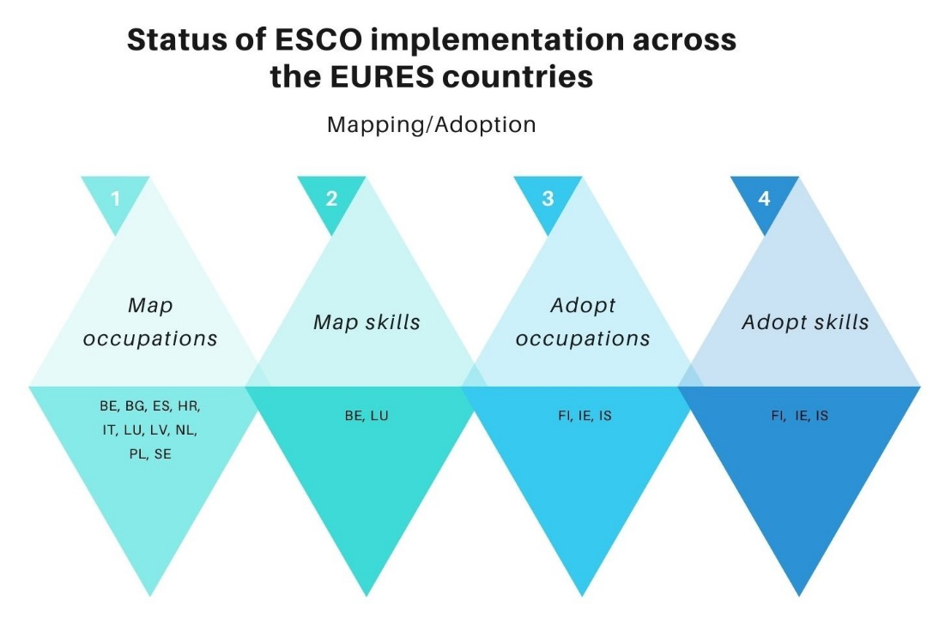

- 10 EURES countries have completed the mapping of occupations
- 2 EURES countries have completed the mapping of skills
- 3 EURES countries have adopted occupations
- 3 EURES countries have adopted skills

Member States use various approaches to carry out the mapping. These are:

- artificial intelligence models;
- “human” approach, i.e. experts in the Member States carry out the mapping exercise manually;
- hybrid approach combing approaches one and two.

Main challenges of the mapping exercise
As displayed in the infographic above, ten countries (30% of the EURES countries) have completed the mapping of occupations and two countries (7% of the EURES countries) the mapping of skills. When it comes to adoption, three countries (10% of the EURES countries) have proceeded with the adoption of occupations and another three (10% of the EURES countries) with the adoption of skills.

This section provides an overview of the challenges encountered by mappers in the EURES countries that deter them from completing the mapping exercise. These can be classified in three categories: general, content-related and technical.

General challenges
- The establishment of mapping relations and processing of mapping tables is a technical exercise which requires basic digital and data management competences.
- The Commission has prepared and published on the ESCO portal and the mapping platform guides/manuals which detail processes relevant to the mapping, such as how to structure the mapping tables, how to establish mapping relations and how to import them into the mapping platform. Sometimes, mappers carry out these processes without consulting the aforementioned guides. This results in errors and delays.

Content-related challenges
- Quantitative completeness: for the occupations the goal is to have a mapping that is quantitative-wise complete, i.e. each ESCO occupation is mapped to at least one occupation in the national classification and the other way around. Even in cases where there is no equivalent concept in ESCO for a concept in the national classification, the latter can still be mapped to the relevant ISCO unit group that serves as the broader occupation in ESCO.

For the skills, a complete mapping is not envisaged due to the following:
• the skills pillar does not aim for a complete coverage of all skills and
• there is less similarity between skill classifications than there is between
occupational classifications, which makes mapping skills challenging.

Problem: Very often mappers leave occupations unmapped. Unmapped mapping relations render the mapping table incomplete.
- Qualitative completeness: a mapping table of occupations/skills is considered qualitative-wise complete when a. all occupations/skills in one classification have at least one correspondence in the other one (mapping pair) and b. when each such correspondence is accompanied by a mapping relation, i.e. exact match, close match, more general than, more specific than.

Problem: Often mappers establish correspondences omitting to indicate mapping relations. For example, cocineros de barco (ship cook) corresponds to cocineros (cooks). The mapping relation, i.e. in this case cocineros de barco (ship cook) is “more specific than” cocineros (cooks) is missing. Missing mapping relations render the mapping table incomplete and inaccurate.
- All mapping pairs should be unique: a mapping pair should be defined by only one mapping relation.

Problem: The same mapping pair has two or more different mapping relations. For example, if cocineros de barco (ship cook) is more specific than cocineros (cooks), it cannot be also a close match to cocineros (cooks). Such cases are referred to as conflicting mappings and should be avoided/corrected.
- ISCO unit groups constitute the hierarchy of the ESCO occupations. When mappers have exhausted all options and are unable to establish a mapping relation between an occupation in their national classification and another one in ESCO, they should establish a “more specific than” relation to an ISCO unit group (4th level ISCO). The relation to an ISCO unit group provides the Commission with an indication of what the occupation is about. Leaving an occupation unmapped provides zero information of what it is about and renders the mapping table incomplete.

Problem: Often mappers a. are not aware of the possibility to map ESCO occupations to ISCO unit groups and leave occupations in their national classification or in ESCO unmapped when unable to find a pair in the other classification and b. establish inverse mapping relations to ISCO unit groups, i.e. ISCO unit group is “more specific than” an ESCO occupation. This is wrong. ISCO unit groups can never be narrower to ESCO occupations.
- When an occupation in a national classification is broader than an occupation in ESCO, the first one should be mapped as “more general than” to the latter one and vice versa when an occupation in a national classification is narrower than an occupation in ESCO.

Problem: Often mappers establish inverse mapping relations when it comes to broader/narrower mappings, i.e. they map a broader occupation in a national classification as “more specific than” to ESCO. This is wrong.

Technical-related challenges
- The Commission recommends - as a quality assurance mechanism - that EURES countries carry out a bi-directional mapping, i.e.: from ESCO to their national classifications of occupations/skills, and from their national classifications of occupations/skills to ESCO. Mapping from the opposite direction provides the user with another perspective and may result in different mapping relations. When carrying out a bi-directional mapping, mappers end up with two mapping tables which they should compare and merge into one by resolving conflicting relations.

Problem: Very often mappers provide two mapping tables with conflicting mapping relations instead of one clean table. This is wrong. All mapping correspondences should be captured in only one mapping table with unique mapping pairs.
- The EURES Regulation stipulates that EURES countries create mapping tables in accordance with common technical standards and formats. Those EURES countries who opt to use the ESCO mapping platform, can get an export of their mapping table in the aforementioned standards and formats automatically. For those EURES countries who opt to use excel files instead (or any other type of format), the Commission has made available on the ESCO portal a document explaining the technical standards and formats with which the files should comply.

Problem: Very often mappers a. do not use the common standards and formats laid down by the Commission. Instead, they provide the mapping table in formats of their preference or b. use the common standards and formats incorrectly, e.g. header section is incorrect, columns are missing, columns exist but are empty, csv separator is incorrect and more.
- Part of the data requested in the technical standards and formats is the ESCO URIs.

Problem: Often mappers add ESCO URIs which do not exist.
- Several EURES countries who opt to create their mapping tables using external files, wish to benefit, nevertheless, by the functionalities of the ESCO mapping platform. Benefits can vary from having their data centralised and stored in the Commission system and/or make use of the statistics the platform offers. They can achieve that by importing their table(s) into the mapping platform.

Problem: Albeit existing documentation on how to import external files into the mapping platform, mappers experience difficulties. Therefore, and in order to avoid further delays in the submission of the mapping tables, the Commission is supporting Member States in importing such files into the mapping platform.

Support by the Commission to the Member States
The Commission supports the Member States in the implementation process in the following forms:

- ESCO mapping platform: the platform is an IT application designed to help Member States map their national classifications to ESCO.
- Mapping manual: a step-by-step guide for mapping NOCs and NSCs to ESCO or replacing them with ESCO.
- Trainings in the form of webinars and workshops.
- Visits - upon request - to the Member States.
- ESCO Helpdesk: a central European contact point to clarify difficult/ambiguous cases composed of a team of experts who reply to enquiries received by the mappers. The ESCO helpdesk is accessible via EMPL-ESCO-SECRETARIAT@ec.europa.eu
- The Commission launched the call for proposals VP/2019/010 "EURES: support to national classification inventories and innovative national online services for mobile workers". The aim of the call was to financially and technically support Member States to comply with the obligations under Article 19 of Regulation (EU) 2016/568. Eight countries applied to the call.
- Pilot projects on mapping: projects between the Commission services and the Public Employment Services (PES) from Member States aimed at establishing mapping relations between ESCO occupations and NOCs, and ESCO skills and NSCs. The results of these pilot projects are available on the ESCO portal and can serve as learning resources.

EURES is the network of European employment services which aims to provide information, advice and recruitment and placement services for workers and employers.
Regulation (EU) 2016/589, OJ L 107, 22.4.2016
The data that we present stem from information that has been communicated to the ESCO team of the Commission. This means that this list is not exhaustive and there could be EURES countries who map/adopt without having communicated it to the Commission and thus they are not included in this list.
No country visit was realized in 2020 and 2021 due to Covid-19.
The list of the awarded grants is available at: https://ec.europa.eu/social/main.jsp?catId=632&langId=en.

