



Mapping ESCO occupations to NACE

Technical Report – July 2025

Table of Contents
1 Introduction 2
2 Mapping methodology 3
2.1 Data 5
2.2 Identify NACE class candidates 5
2.3 Manual validation 7
2.3.1 Mapping guidelines 7
2.3.2 Decision process for manual validation 8
2.4 Quality assurance 8
3 Resulting mapping table 10
4 Exploring ESCO through NACE 12
5 Consultation on the NACE mapping 13
6 Updating the mapping to NACE Rev. 2.1 15
7 Summary 16

Introduction

The Commission has a continuous process in place for maintaining ESCO, which results in improving existing content and adding supporting structured information to the ESCO knowledge graph. Within this context, mapping ESCO to other relevant classifications for the European labour market is an important focus. This document details the work on mapping ESCO occupation concepts to the Statistical classification of economic activities in the European Community (NACE).
The underlying aim for enriching ESCO with relevant metadata from the labour market is to enable the classification to be a more comprehensive knowledge graph and better serve the needs of its stakeholders in terms of job matching, statistical analysis, skills intelligence and informing educational programmes. The newly established mapping to NACE provides an alternative view compared to the existing hierarchy based on the International Standard Classification of Occupations (ISCO), where occupational groups are primarily grouped in terms of skill level and specialisation. In contrast, mapping ESCO occupations to NACE allows identifying groups of occupations by economic sector.
In order to map ESCO v1.2.0 to NACE Rev. 2, the Commission developed methodology that combines manual validation with advanced data science methods and ontological mapping guidelines. This approach aimed to map each ESCO occupation to NACE categories at the lowest level (i.e. 4-digit NACE classes), where the ESCO concept is intended to be more narrow than the NACE category.
Section 2 provides an overview of the mapping methodology, while Section 3 presents the outcome of this approach. Examples of how these mapping relations allow to explore ESCO are provided in Section 4. Finally, Section 5 presents a summary of the work.

Mapping methodology

The process for mapping ESCO occupations to NACE categories consists of three steps:
- Identification of a list of candidate NACE categories to which the ESCO occupations can potentially be mapped by means of data science techniques.
- Carrying out a manual validation process according to ontological mapping guidelines to select the most appropriate NACE category candidates.
- Performing quality assurance (QA) on the established mappings following a predefined procedure.
This process resulted in a mapping table where each ESCO occupation was mapped to at least one NACE category.
The following sections provide detailed insights for the data that are considered for the approach, data science techniques, manual validation strategy and the QA process. An overview of the process is described in Figure 1.

Figure 1: Process for mapping ESCO v1.2.0 occupations to NACE Rev. 2.

Data

The complete list of 3,039 occupation concepts from ESCO v1.2.0 was mapped to NACE Rev.2. From each ESCO occupation, the preferred term (PT), activities as described in the concept description and the hierarchical position of the concept in the ISCO hierarchy were used. NACE Rev.2 provides a hierarchical structure of 4 levels:
- Level 1: 21 sections, e.g. C – Manufacturing
- Level 2: 88 divisions, e.g. 25 – Manufacture of fabricated metal products, except machinery and equipment
- Level 3: 272 groups, e.g. 25.9 – Manufacture of other fabricated metal products
- Level 4: 615 classes, e.g. 25.91 – Manufacture of steel drums and similar containers
Where possible, the ESCO occupations are mapped to the 615 lowest level NACE classes, from which the following information was used: class description, inclusion criteria, exclusion criteria, position of the class in the NACE hierarchy. The inclusion and exclusion criteria refer to the fields this item includes, this item also includes, rulings, this item excludes which provide lists of activities that are in or out of scope for the NACE class. EURES online job advertisements were considered when they included both links to ESCO occupation concepts and NACE class concepts.

Identify NACE class candidates

The initial step in the methodology is to identify from all 615 NACE classes a limited set of the most appropriate candidates for each ESCO occupation. Additional metadata is computed for each of these candidates. In this way, the more extensive and time-consuming manual validation process can focus on a limited number of NACE classes (cf. Section 2.3). The following natural language processing and data science techniques are core to this step:
- A finetuned language model was used to compare ESCO occupation PTs and descriptions with the content of the NACE class description, this item includes, this item also includes, rulings fields. This resulted in semantic similarity match scores between ESCO concepts and NACE classes that allowed ranking the latter.
- The NACE class candidates with higher semantic similarity were supported with available ESCO occupation/NACE class correspondence statistics as extracted from EURES online job advertisements.
- Further supporting metadata were computed to measure whether NACE classes were coherently suggested as candidates for ESCO occupations that originate from the same ISCO class. This was to provide a more holistic perspective for the NACE class suggestion.
This step prepared all the data that was used for manual validation of the NACE class candidates. Table 1 provides an example of the resulting information for the ESCO occupation watch and clock repairer belonging to ISCO group 7311 – Precision-instrument makers and repairers.

Overall match score | NACE class description | Inclusion criterion max match score | Maximum match inclusion criterion | ISCO – NACE coherence ratio | EURES frequency
0.97 | S95.25 – Repair of watches, clocks and jewellery | 0.96 | repair of watches, clocks and their parts such as watch cases and housings of all materials; movements, chronometers, etc. | 5/6 | 13
0.95 | C26.52 – Manufacture of watches and clocks | 0.93 | manufacture of watch and clock cases, including cases of precious metals | 5/6 | 12
0.84 | C32.12 – Manufacture of jewellery and related articles | 0.91 | manufacture of precious metal watch bands, wristbands, watch straps and cigarette cases | 4/6 | 6
Table 1: NACE class candidates with supporting data for the ESCO occupation watch and clock repairer. This information is used as input for the manual validation step.

The following overview provides detailed information for the columns presented in Table 1:
- Overall match score: Language model based semantic similarity between the ESCO occupation PT and description with respect to the NACE class description and all corresponding inclusion criteria. Higher scores indicate a more likely semantic match between the ESCO occupation and the NACE class as a whole.
- NACE class description: Textual description of the corresponding NACE class.
- Inclusion criterion max match score: Language model based maximum of semantic similarity between the ESCO occupation PT and description with respect to all the specific inclusion criteria of the NACE class. NACE class inclusion criteria often consist of lists of detailed subcriteria. This score aims to detect the subcriterion from the longer list having the highest semantic overlap with the ESCO occupation. This can help manual validation to focus on the most relevant parts of the inclusion criteria.
- Maximum match inclusion criterion: Subcriterion extracted from the NACE class inclusion criteria having the largest match score with respect to the ESCO PT and description. Higher scores indicate a more likely semantic match between the ESCO occupation and the subcriterion from the NACE class criteria.
- ISCO – NACE coherence ratio: The share of ESCO occupations within the ISCO group having the NACE class as candidate suggestion. For each combination of ESCO occupation and NACE class suggestion, this ratio indicates the ratio of the number of ESCO occupations within the same ISCO group also having the NACE class suggestion over the total number of ESCO occupations in the ISCO group. For example, 5 out of 6 ESCO occupations within ISCO group 7311 – Precision-instrument makers and repairers have NACE class S95.25 – Repair of watches, clocks and jewellery as a candidate (Table 1). This ratio allows to identify NACE categories that are more suitable candidates across the ISCO group and helps to obtain a certain level of consistency in mapping the ESCO occupations hierarchy.
- EURES frequency: Number of online job advertisements in EURES that have in the metadata both the corresponding NACE class and the ESCO occupation.

Manual validation

The next step of the mapping process consists of manual validation in order to identify the most accurate NACE class from the candidates for each ESCO occupation. This phase consists of first establishing and then carefully applying mapping guidelines while interpreting the information as coming out of the data processing as described in Section 2.2.
The following sections provide information on the mapping guidelines and the decision process during manual validation while Figure 2 provides a graphical summary.

Mapping guidelines

Ontological mapping guidelines for linking ESCO occupations to NACE classes were established upfront and refined over time. Examples of such guidelines are:
- Using a holistic perspective where both the hierarchical allocation of the ESCO concept and the NACE class are considered during the mapping
- Interpreting the description of the ESCO concept and the NACE class before carrying out the mapping in contrast to solely relying on titles
- Interpreting the NACE class inclusion and exclusion criteria
- Maintaining consistency in the mapping as ESCO occupations are part of a hierarchy. Occupations that are part of the same ISCO/ESCO subtree in the hierarchy are more likely mapped to similar NACE categories.
- Mapping to the lowest level of NACE categories (i.e., NACE classes). If broader categories apply, validators needed to go up in the NACE hierarchy to find the appropriate mapping.
- Mapping one ESCO occupation to multiple NACE concepts if an occupation covered aspects pertaining to more than one NACE category
- Ideally, a mapping is supported by corresponding statistics as observed in online job advertisements

Decision process for manual validation

Based on the provided data and the mapping guidelines, validators followed the decision process as articulated in the following steps:
- Validators would preferably establish a mapping between an ESCO occupation and only one of the NACE class candidates
- If a mapping between an ESCO occupation and a single NACE class could not be established, validators would search for a higher-level NACE category (i.e., NACE groups, divisions or sections from lowest to highest level) to map the occupation to
- When an ESCO occupation was relevant for more than one NACE category, validators would map it to multiple NACE categories (preferably NACE classes). If relevant for higher NACE categories, then the mapping would happen with multiple NACE groups, divisions or sections.
- Based on the reasoning in points 1, 2 and 3, validators decided whether to accept or discard the mapping candidate. If in doubt, they would flag the case.
- In case none of the suggested mappings was accepted, the validator would add an appropriate NACE category by searching manually.
- Validators also had the option to provide comments for any combination of ESCO occupation and NACE category candidate.

Quality assurance

Finally, a quality assurance step was implemented to review established mappings as resulting from Section 2.3:
- Doubt cases as flagged by the validators were revised and a decision was taken on the final mapping
- Established mappings were cross-checked with a previous (partial) mapping of ESCO to NACE. Conflicting cases were investigated and resolved.
- Spot checks on the consistency of the mapping approach were also made (i.e., extensive use of multiple mappings or frequent mappings to NACE groups, divisions or sections instead of classes).
Figure 2: Overview of the validation process.

Resulting mapping table

Once the review process of Section 2.4 was completed, a final mapping table with the following columns was constructed (Figure 3):
- ESCO URI: URI of ESCO occupation to be mapped
- ESCO PT: Preferred term of ESCO occupation to be mapped
- ESCO description: Description of ESCO occupation to be mapped
- NACE code: Identifier of mapped NACE category
- NACE title: Title of mapped NACE category

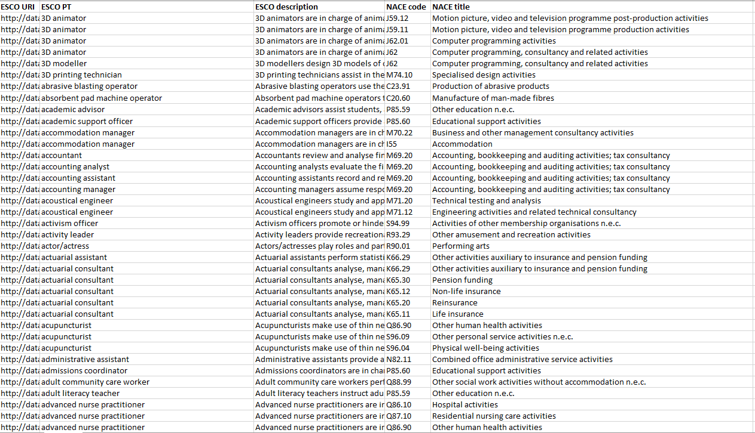
Figure 3: Resulting ESCO to NACE mapping table.

Each of the 3,039 ESCO occupations was mapped to at least one NACE category. The final mapping table resulted in a total of 4,632 mappings. This number showed that each ESCO occupation was mapped to around 1.5 NACE categories and, although multiple mappings were used, the ontological guideline to map ESCO to preferably only one NACE category was the most common mapping scenario. In addition, most of the mappings (i.e. 3,986/4,632) were made from ESCO occupations to NACE classes (the lowest hierarchical level of NACE categories).
Table 2 presents the distribution of ESCO occupations for NACE sections. All mappings for an ESCO occupation were allocated to their corresponding NACE section and a relative weight was computed for each ESCO occupation - NACE section combination. The relative weight represents the share of mappings the ESCO occupation had for the NACE section. These relative shares were aggregated, rounded and depicted as Mapped ESCO occupation count in Table 2. Column Mapped ESCO occupation percentage normalises these counts over all NACE sections.
NACE section | Mapped ESCO occupation count | Mapped ESCO occupation percentage
A – Agriculture, forestry and fishing | 89 | 2.93
B – Mining and quarrying | 38 | 1.26
C – Manufacturing | 754 | 24.81
D – Electricity, gas, steam and air conditioning supply | 39 | 1.29
E – Water supply; sewerage, waste management and remediation activities | 38 | 1.25
F – Construction | 121 | 3.99
G – Wholesale and retail trade; repair of motor vehicles and motorcycles | 278 | 9.16
H – Transportation and storage | 143 | 4.71
I – Accommodation and food service activities | 41 | 1.35
J – Information and communication | 176 | 5.78
K – Financial and insurance activities | 63 | 2.08
L – Real estate activities | 13 | 0.41
M – Professional, scientific and technical activities | 402 | 13.21
N – Administrative and support service activities | 125 | 4.11
O – Public administration and defence; compulsory social security | 135 | 4.44
P – Education | 175 | 5.77
Q – Human health and social work activities | 150 | 4.92
R – Arts, entertainment and recreation | 156 | 5.13
S – Other service activities | 92 | 3.01
T – Activities of households as employers; undifferentiated goods- and services-producing activities of households for own use | 10 | 0.31
U – Activities of extraterritorial organisations and bodies | 2 | 0.06
Table 2: Distribution of ESCO occupations by NACE section. Note: values in column Mapped ESCO occupation count were rounded to the nearest integer value.

Table 2 shows that NACE sections C – Manufacturing, M – Professional, scientific and technical activities, G – Wholesale and retail trade; repair of motor vehicles and motorcycles and J – Information and Communication contain the largest amount of ESCO occupations, i.e. 754, 402, 278 and 176 respectively. These results can be expected as C – Manufacturing represents a very broad NACE section including the largest number of divisions (i.e. 24), thus covering a wide variety of activities related to manufacturing. Section M – Professional, scientific and technical activities contains 7 divisions with activities ranging from legal, accounting, management consultancy, scientific research, advertising to veterinary. This variety of activities results in a larger number of ESCO occupations being mapped to this section. Finally, section G – Wholesale and retail trade; repair of motor vehicles and motorcycles includes wholesale and retail activities from a wide range of areas such as motor vehicles, agricultural materials, food, beverages, household goods, which again relates to a significant amount of ESCO occupations.

Exploring ESCO through NACE

Currently, ESCO occupations are organised in a hierarchical structure that is based on the ISCO-08 hierarchy, which was developed by the International Labour Organization (ILO). The first 4 levels of the ESCO occupations hierarchy replicate ISCO-08 and, depending on the unit group, up to 4 additional levels were added. By design, the logic on how occupations are represented in the ESCO hierarchy is inherited from the methodology behind structuring ISCO-08.
The ISCO-08 methodology for creating hierarchical levels was developed based on the concept of skill level, which was defined as a function of the complexity and range of tasks and duties to be performed in an occupation. In practice, skill level in ISCO-08 spans 4 levels and is related to:
- the nature of the work performed in an occupation in relation to the characteristic tasks and duties defined for each ISCO-08 skill level
- the level of formal education defined in terms of the International Standard Classification of Education (ISCED-97) required for competent performance of the tasks and duties involved
- the amount of informal on-the-job training and/or previous experience in a related occupation required for competent performance of these tasks and duties
The practical consequence of this approach is that ESCO occupations from the same sector are spread around in the hierarchy. Figure 4 (left panel) shows an example with occupations building construction worker, construction general supervisor, road construction supervisor, sewer construction worker and road construction worker. These occupations are part of four different top-level groups in the ISCO-based hierarchy for ESCO, i.e. Technicians and associate professionals, Craft and related trades workers, Plant and machine operators and assemblers and Elementary occupations. Currently, it is not possible to identify and aggregate occupations from the same sector.
With the release of ISCO-08 ILO already reported that due to this specific design, a future need could arise to create additional views that provide an alternative approach to aggregate occupational data in terms of thematic groupings. These so-called thematic views could be focused primarily on goods and services produced rather than skill level. However, to date no complete systematic allocation of ISCO unit groups to thematic views has been published.

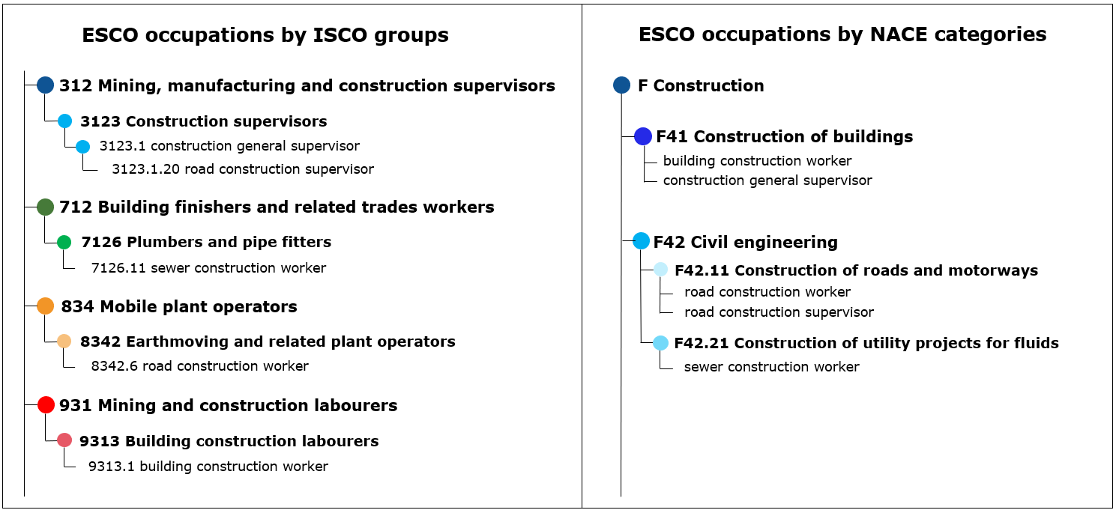
Figure 4: Existing ISCO-based hierarchy (left panel) and alternative NACE-based hierarchy (right panel) for ESCO occupations.

Given the relevance in having aggregation by sector, the Commission decided to provide the necessary data to offer an alternative approach for grouping ESCO occupations that is based on economic activities via NACE. Figure 4 (right panel) illustrates this by presenting a NACE-based grouping of the same five construction-related occupations. All five occupations are part of the same NACE section F – Construction (level 1) and these occupations cover 2 different NACE divisions (level 2): F41 – Construction of buildings and F42 – Civil engineering. This example shows the potential to efficiently aggregate ESCO occupations based on NACE and that this offers new capabilities which are currently not possible with the existing structure. These data can serve new applications in statistical reporting, skills intelligence or job matching.

Consultation on the NACE mapping

The ESCO-NACE crosswalk consultation was launched on 1 February 2025. Participants were selected via a public survey opened on 20 December 2024 to allow stakeholders to express their interest in this consultation. Once the consultation started, participants received the mappings between ESCO occupations and NACE categories.
All participants had the opportunity to provide their feedback until 15 March 2025. The final list of participants is shown in Table 3 below.

Organisation/Company name | Organisation type | Country
SkillLab | Private Sector Company | Netherlands
Orkestra - Basque Institute of Competitiviness | Research/Statistical office | Spain
Arbeids- og velferdsdirektoratet | Public Employment Service or other Public Authority | Norway
APIROPLUS Solutions Ltd. | Private Sector Company | Cyprus
Akademias | Private Sector Company; Education Provider | Iceland
Centru de Dezvoltare si Management | Other (NGO) | Moldova
REFORMED aisvl | Education Provider; Other (organisation international INPA for accreditation) | eur : BE FR IT GE LU IT PT RO Int DZ JP
Web2Learn | Private Sector Company | Greece
XOBOL | Private Sector Company | Greece
Instituto de la Construcción de Castilla y León | Other (Private non-profit scientific and cultural foundation) | Spain
Table 3: List of participants for the NACE mapping consultation

The participants for the NACE consultation received the file shown in Figure 5 below.

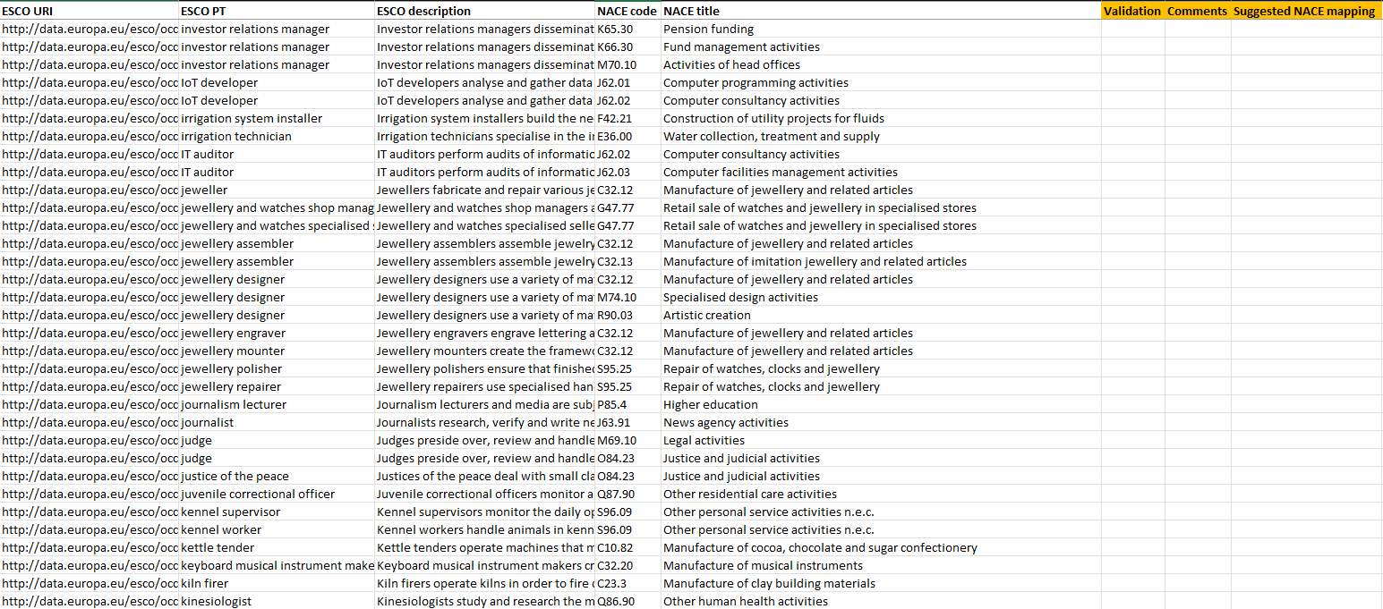
Figure 5: The version of the ESCO-NACE mapping used for the consultation

Each participant was asked to provide feedback through the following procedure:
- Validate the mapping by filling in the column “Validation” with either “Accept” or “Discard” namely to accept or discard the mapping
- Provide comments on the mapping in the column “Comments”
- Fill in the column “Suggested NACE mapping” with the suggested alternative or additional NACE mappings. In case the mappings were discarded, participants were requested to fill in the column “Suggested NACE mapping” with an alternative NACE category for the ESCO occupation to be mapped

At a subsequent stage, the ESCO Secretariat collected the feedback from the participants of the consultation and merged the various responses into one dataset to analyse and draw comparison across all of the responses. The process of establishing the correct NACE mapping based on the feedback from the consultation involved several steps:
- If all stakeholders accepted the mapping, then the mapping between the ESCO occupation and NACE was confirmed
- If all the stakeholders discarded the mapping and provided an alternative one, the latter was used
- When some stakeholders accepted the mapping and others discarded it and provided an alternative one, the ESCO Secretariat analysed the various options and kept the most suitable one. In case both the accepted mappings and the suggested alternatives were considered suitable, the ESCO Secretariat established multiple mappings
- If all the stakeholders did not validate the mapping or discarded it without providing alternatives, the ESCO Secretariat further analysed the mapping and decide whether to keep the proposal or to search for an alternative NACE category to map. In case the occupation was mapped to multiple NACE categories and some were accepted while others were not validated or discarded, the latter were removed from the crosswalk

Once all the feedback was processed, the dataset was finalised and the mapping of ESCO to NACE was ready to be updated to NACE Rev. 2.1.

Updating the mapping to NACE Rev. 2.1

The validated results of the consultation for the ESCO-NACE mapping with NACE rev. 2 were then updated to the latest version of NACE rev. 2.1. The process entailed three main steps:
- Merge the post-consultation validated ESCO-NACE rev. 2 mapping with the NACE rev. 2.1 correspondence tables to obtain the correspondent mappings to NACE categories in NACE rev. 2.1 starting from NACE rev. 2
- Validate the mappings where a 1-to-1 correspondence between NACE rev.2 and 2.1 was not available for the various NACE categories (sections, divisions, groups and classes)
- Compile the final mapping file where each ESCO occupation was mapped to at least one NACE rev. 2.1 category
- Create a combined file where the headings of the NACE categories were available in the 24 official languages of the EU.

The final ESCO-NACE rev. 2.1 mapping file is available in the ESCO website for download and consultation together with the present technical report.

Summary

This document presents the methodology that was developed for mapping the ESCO v1.2.0 occupation concepts to the Statistical classification of economic activities in the European Community (NACE) Rev. 2 and the subsequent update to the latest version NACE rev. 2.1. The approach is based on manual validation while taking advantage of the latest developments within the fields of artificial intelligence and data science to increase efficiency and quality.
The final version of the crosswalk also includes experts’ input from the industry, which was gathered through a consultation on the initial version of the crosswalk. The post-consultation validated ESCO-NACE crosswalk was then updated to the latest version of NACE rev. 2.1 through a combination of manual validation, desk research and automated methods for data processing.
The resulting mapping table consists of 4,564 mappings for the 3,039 ESCO occupations. The majority of these relations, i.e. 2,504, are mappings to the most detailed level of NACE, i.e. NACE classes.
The mapping table provides additional structured information to ESCO and enhances interoperability, thereby further expanding the ESCO knowledge graph. It allows to explore ESCO occupations from a different perspective compared to the existing ISCO-based hierarchy and offers new opportunities for ESCO stakeholders in terms of job matching, statistical analysis, skills intelligence and informing educational programmes.

https://ec.europa.eu/eurostat/web/nace
https://ilostat.ilo.org/methods/concepts-and-definitions/classification-occupation/
NACE documentation: https://ec.europa.eu/eurostat/web/products-manuals-and-guidelines/-/ks-ra-07-015
ISCO documentation: https://www.ilo.org/sites/default/files/wcmsp5/groups/public/@dgreports/@dcomm/ @publ/documents/publication/wcms_172572.pdf
ISCED-97 documentation: https://uis.unesco.org/sites/default/files/documents/international-standard-classification-of-education-1997-en_0.pdf

